**PLP SOFTWARE ENGINEERING**

**Setting Up Developer Environment**

1. Select Your Operating System (OS): Choose an operating system that best suits your preferences and project requirements.

**Steps for downloading and Installing Ubuntu**

1. **Check your System Requirements**

Ensure your computer meets the system requirements for Ubuntu:

2 GHz dual-core processor

4 GB RAM

25 GB of free hard drive space

1. **Backup your Data**

Backup all important data from your computer to avoid any loss during the installation process.

1. **Download Ubuntu**

Go to the Ubuntu Download Page.

Click on "Download" to get the latest version of Ubuntu.

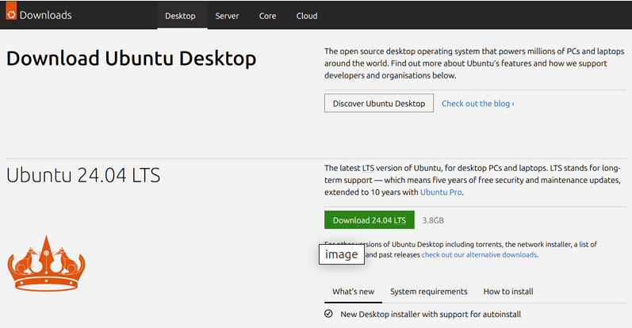

1. **Create installation Media**

**Using Rufus (for Windows users):**

* Download and install Rufus.
* Insert a USB flash drive (minimum 4 GB).
* Open Rufus and select the downloaded Ubuntu ISO file.
* Choose the USB flash drive as the destination and click "Start" to create the bootable USB drive.

**Using Balena Etcher (for macOS and Linux users):**

* Download and install Balena Etcher.
* Insert a USB flash drive (minimum 4 GB).
* Open Etcher, select the downloaded Ubuntu ISO file, choose the USB flash drive as the destination, and click "Flash!" to create the bootable USB drive.

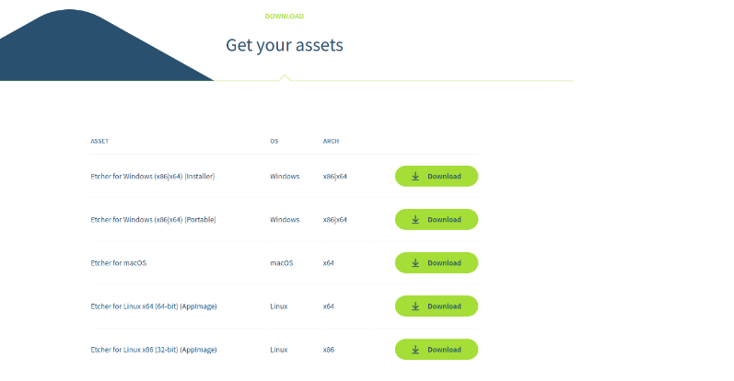

In the above, select the Etcher for linux

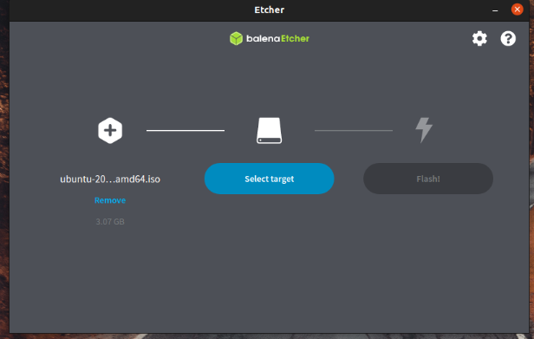

1. **Prepare your Personal Computer for Installation**

* Insert the USB flash drive containing the Ubuntu installation media into your PC.
* Restart your computer.
* Enter the BIOS/UEFI settings (commonly accessed by pressing keys like F2, F12, Delete, or Esc during startup).
* Change the boot order to boot from the USB drive first.

1. **Install Ubuntu**

Boot from the USB drive and follow the installation instructions as shown in the screenshots below.

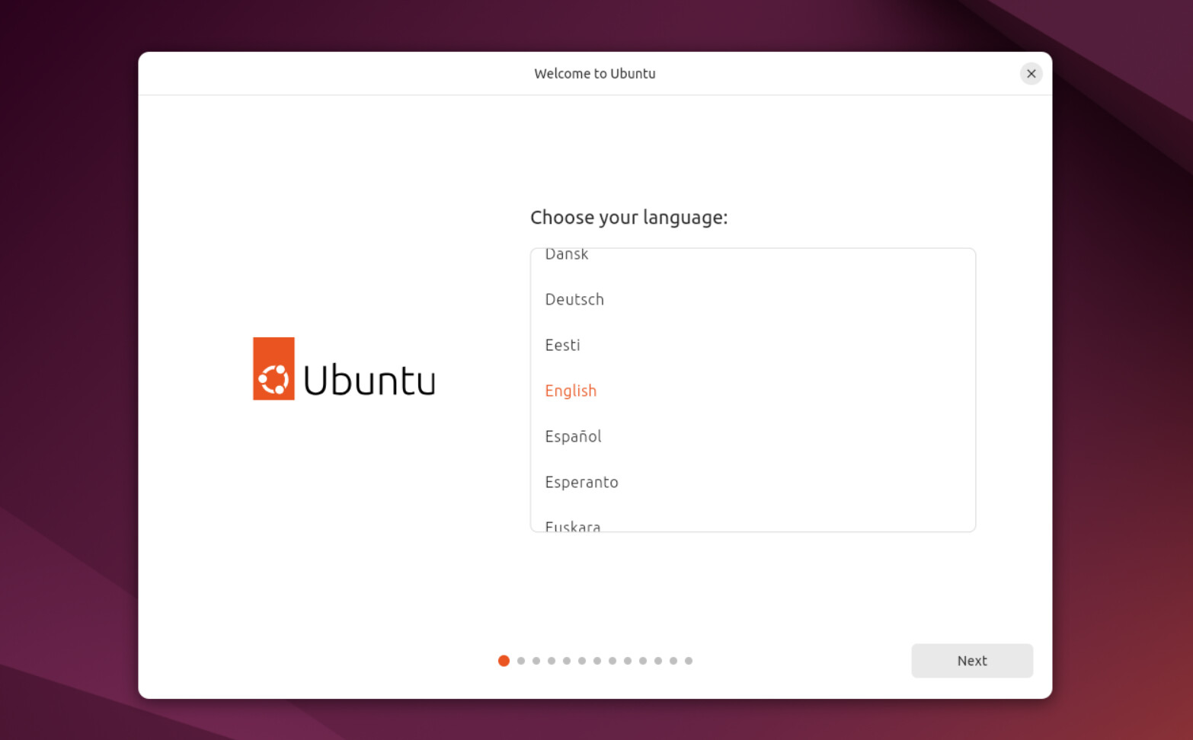

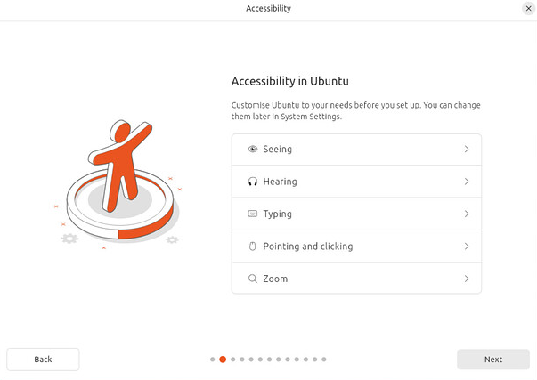

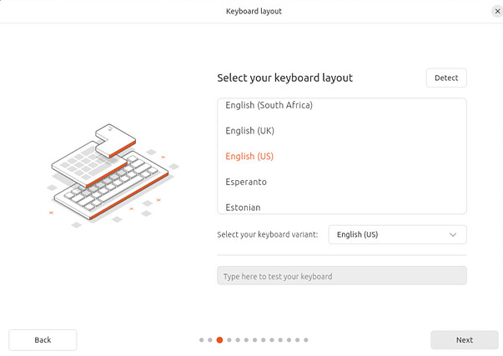

Use wired connection in the case where you have an ethernet cable with internet connected to your pc

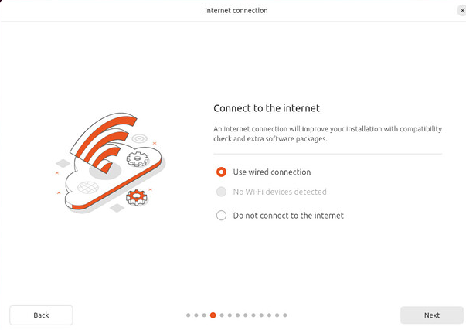

Click Next to install Ubuntu into your pc

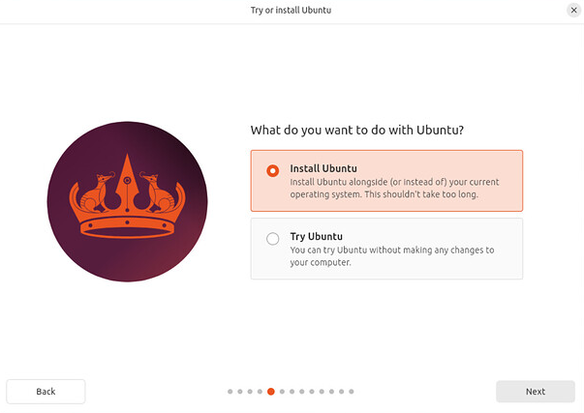

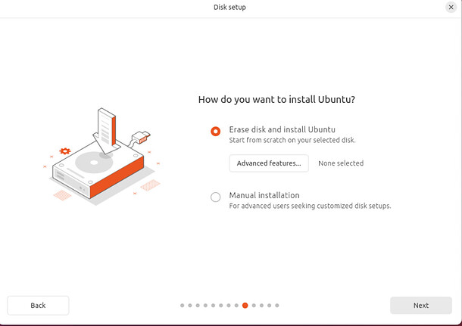

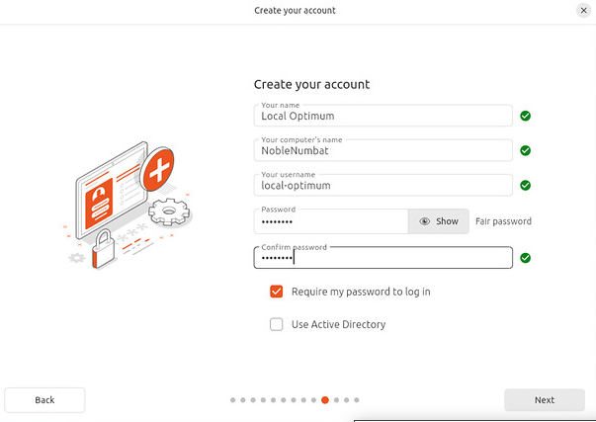

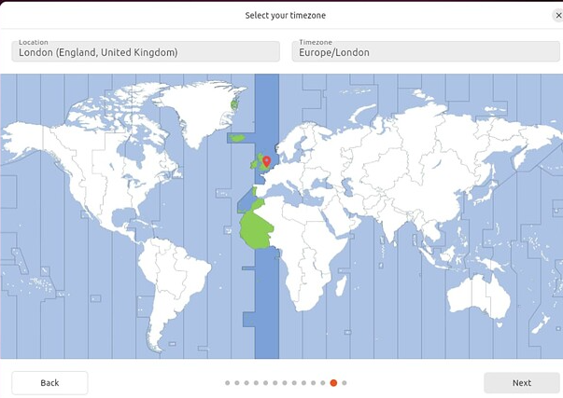

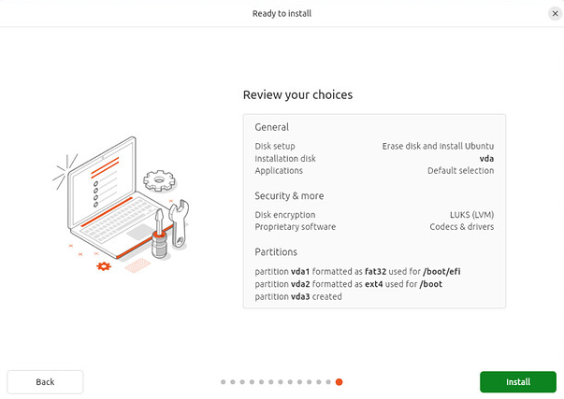

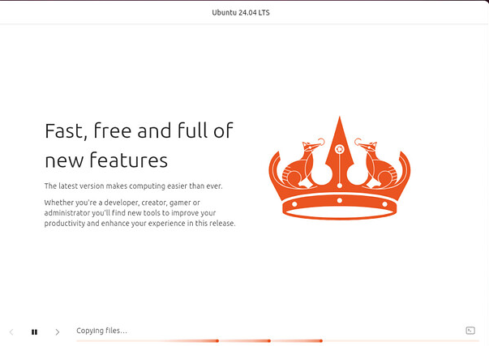

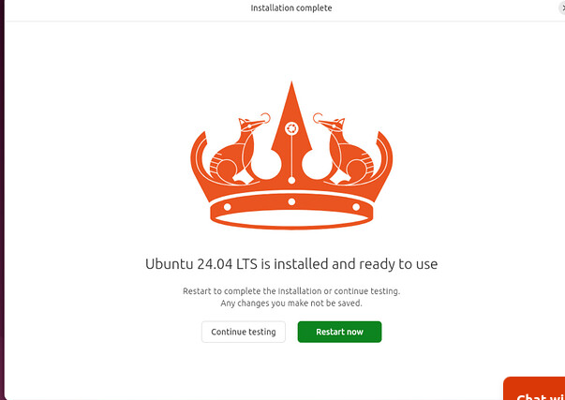

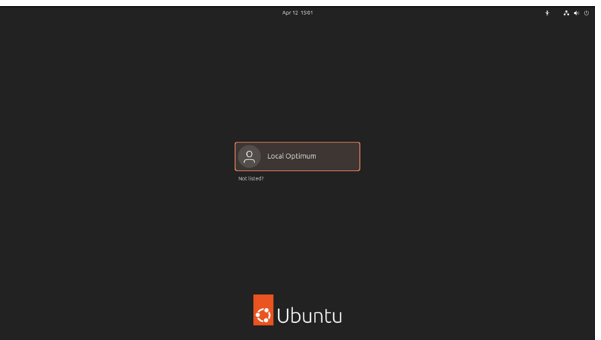

2. Install a Text Editor or Integrated Development Environment (IDE):

Select and install a text editor or IDE suitable for your programming languages and workflow. Download and Install Visual Studio Code.

In linux , you can download the vscode from the ubuntu software or you can also use commands in the terminal

1. Open the ubuntu software

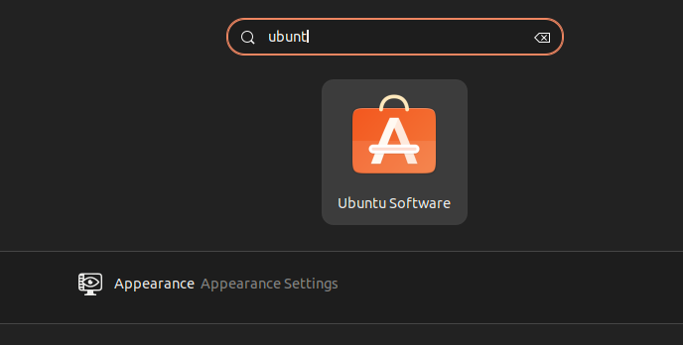

1. Search for vscode in the ubuntu software

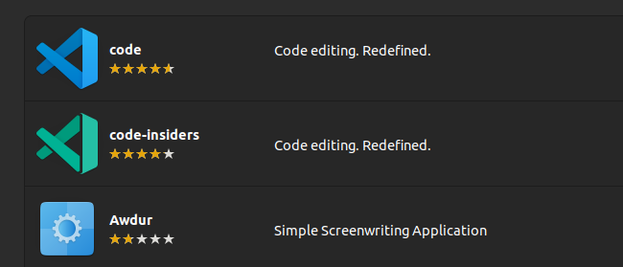

1. Click code then click install

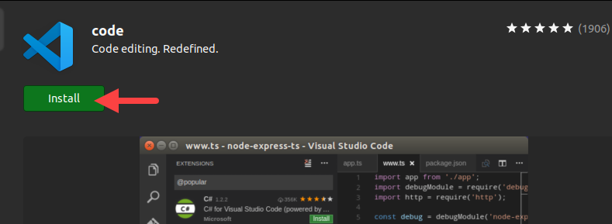

1. It has successfully installed

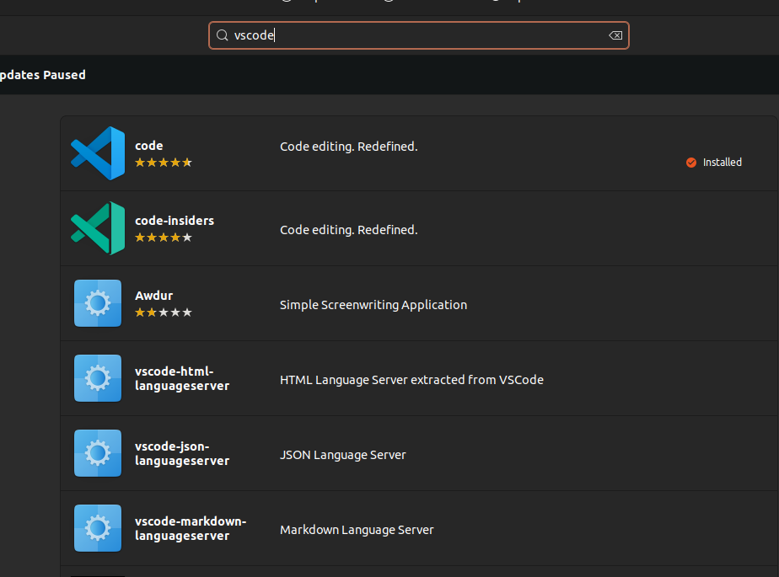

From the terminal it also shows that it is installed

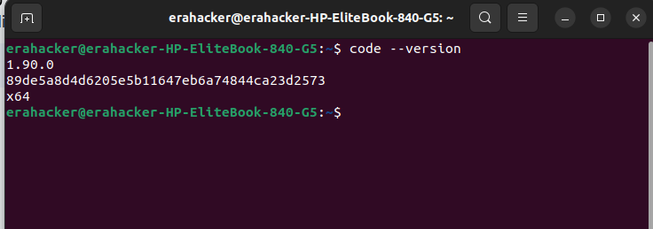

Also from the desktop when I search

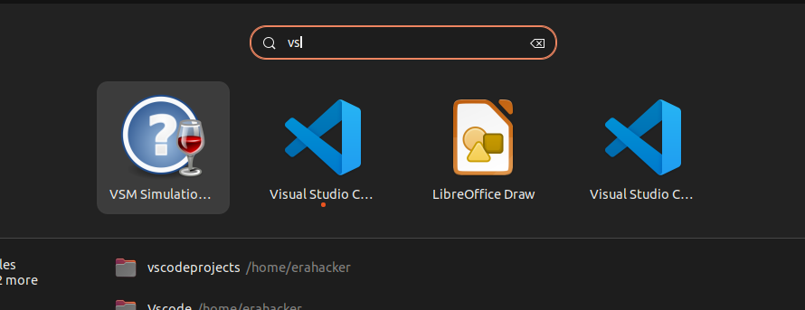

You can now open it to test . just use your terminal and open it

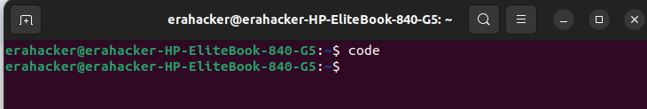

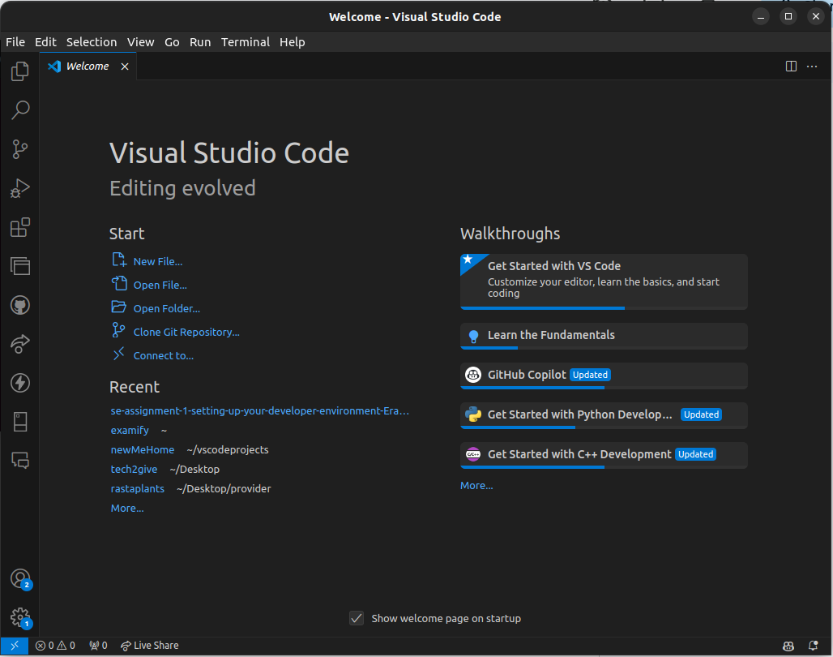

3. **Set Up Version Control System:**

Install Git and configure it on your local machine. Create a GitHub account for hosting your repositories. Initialize a Git repository for your project and make your first commit. https://github.com

1. Run this command in the terminal to install git . and enter your password

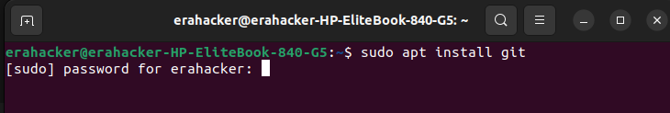

1. Check git version to confirm installation

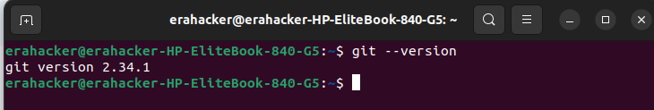

1. Create github account and create a new repository , enter the repository name , set it as either public or private depending on your needs

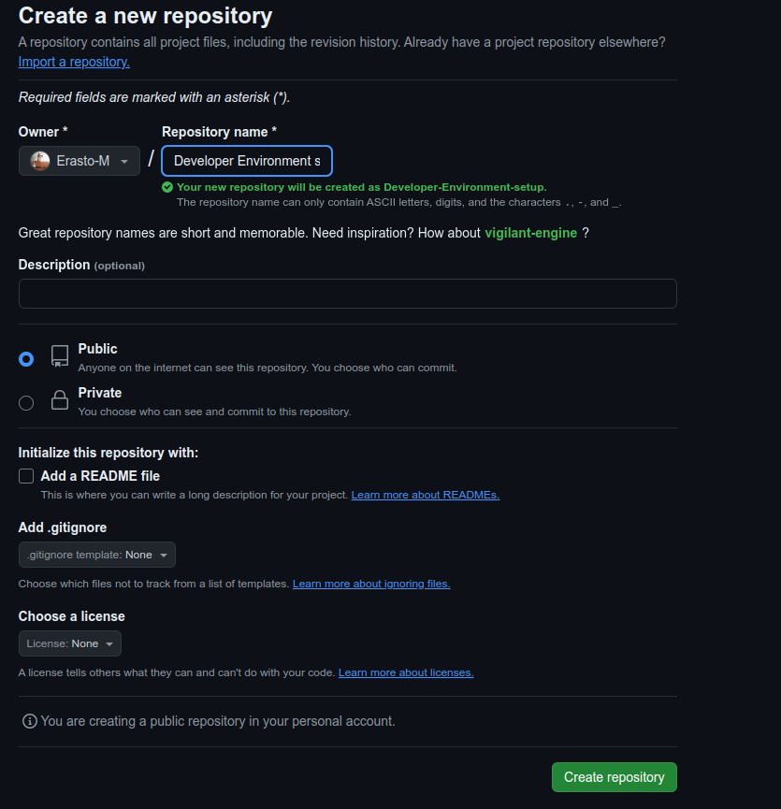

1. Create a folder and open it in vscode , add files to it and then push to Github

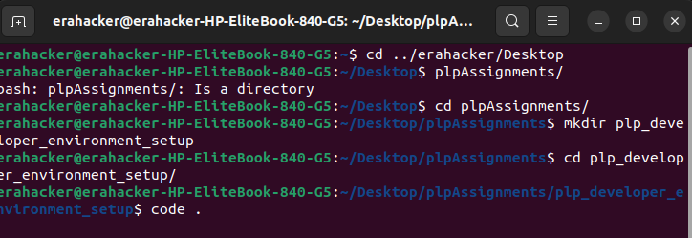

Open it in visual studio code and create two files and then initialize the github repository

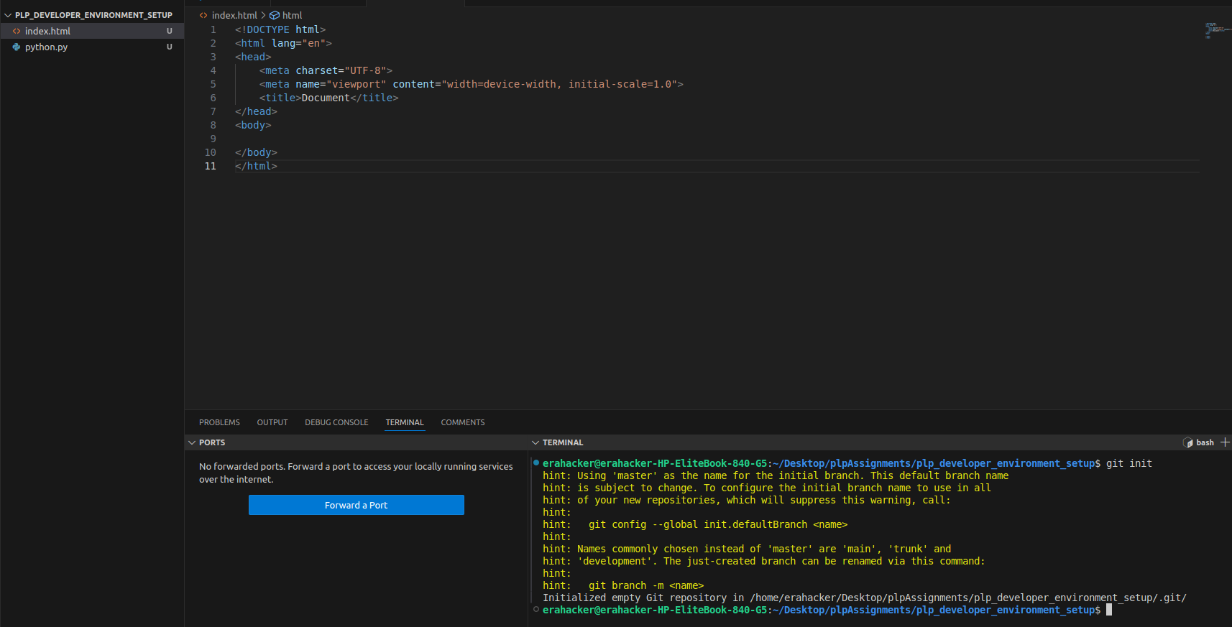

Add the files to tracking , make commits and finally push to the repository you had created in github

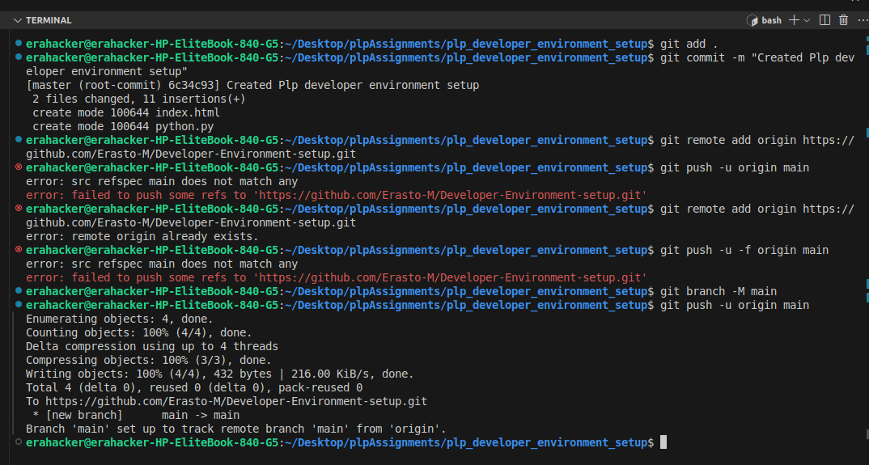

I faced some challenges , had not set the branch main to my local repository , that's why I set it after the second error

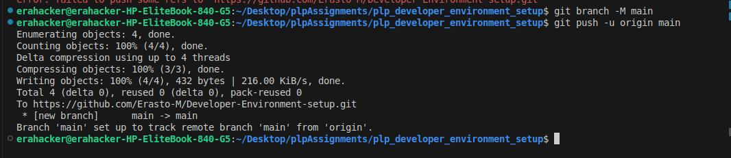

**4. Install Necessary Programming Languages and Runtimes:**

Instal Python from http://wwww.python.org programming language required for your project and install their respective compilers, interpreters, or runtimes. Ensure you have the necessary tools to build and execute your code.

1. Install python in ubuntu using the terminal and its respective installer

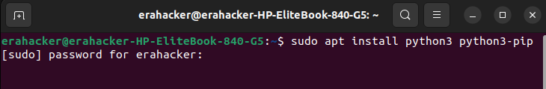

1. Validate their Installation

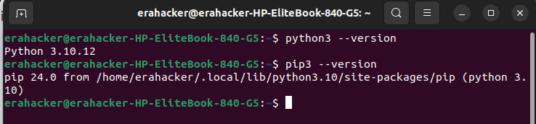

1. Install Virtual environment using this command

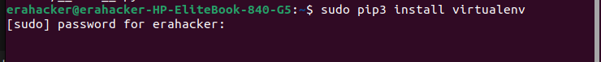

1. **Validate its installation**

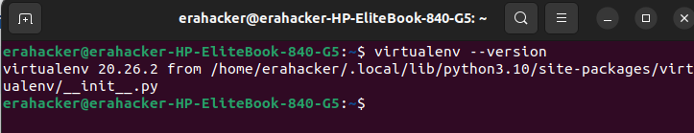

**5. Install Package Managers:**

If applicable, install package managers like pip (Python).

**Already installed using the procedure above for installing python**



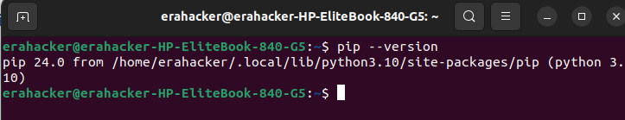

**6. Configure a Database (MySQL):**

Download and install MySQL database

1. Install by running this command the terminal

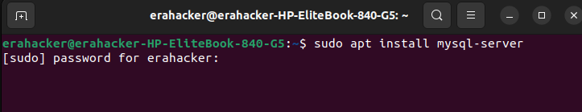

1. Configure MySQL Server:

During the installation process, you will be prompted to set a root password for MySQL. Choose a strong password and remember it.

1. Secure MySQL Installation (Optional but Recommended):

MySQL comes with a script to secure the installation. Run the following command and follow the prompts to secure your MySQL installation:

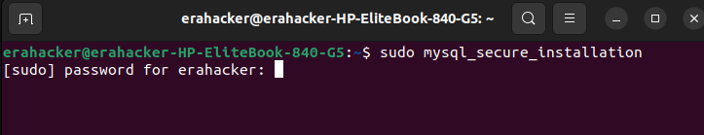

1. Start and Enable MySQL Service:

After installation, MySQL should start automatically. If it's not started, you can start it manually and enable it to start on boot:

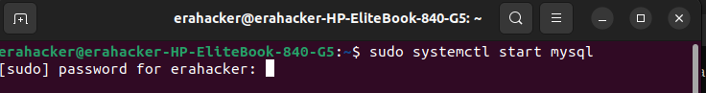

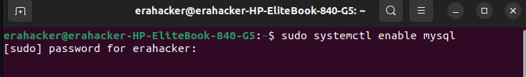

1. Validate installation of mysql

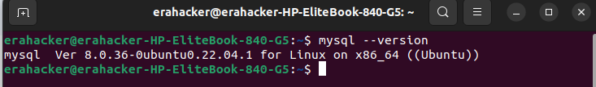

1. Open MySQl and start Using it

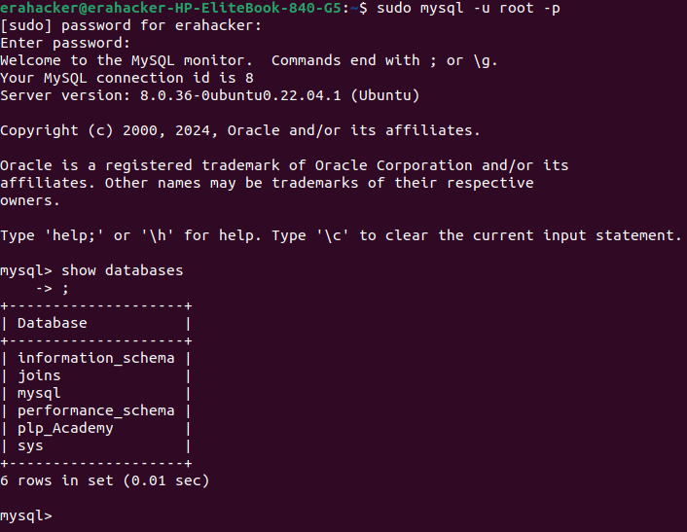

**7. Set Up Development Environments and Virtualization (Optional):**

Consider using virtualization tools like Docker or virtual machines to isolate project dependencies and ensure consistent environments across different machines.

In my case i have installed virtual machine

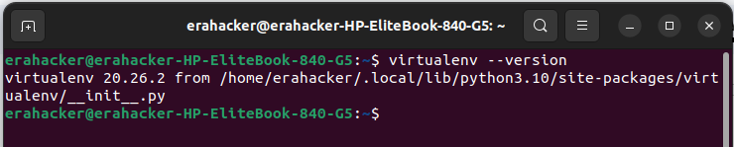

Using the virtual machine to isolate project dependencies

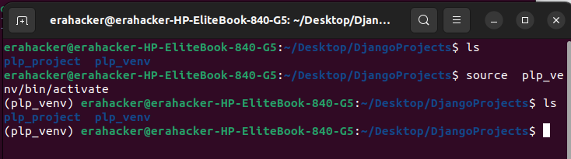

8.  **Explore Extensions and Plugins:**

Explore available extensions, plugins, and add-ons for your chosen text editor or IDE to enhance functionality, such as syntax highlighting, linting, code formatting, and version control integration.

"In Visual Studio Code, open the Extensions sidebar and search for plugins to enhance functionality like syntax highlighting, linting, code formatting, and version control integration."

1. Prettier for code formatting

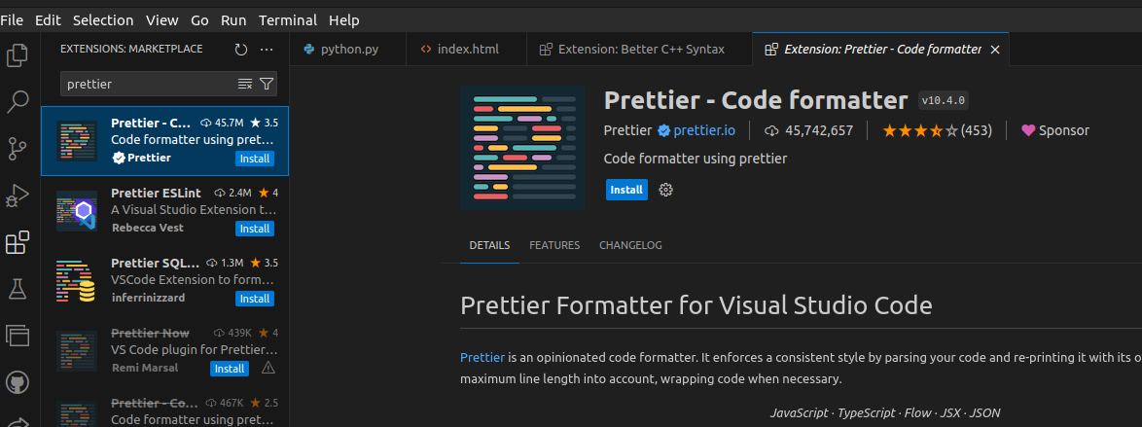

1. Gitlens for version control integration

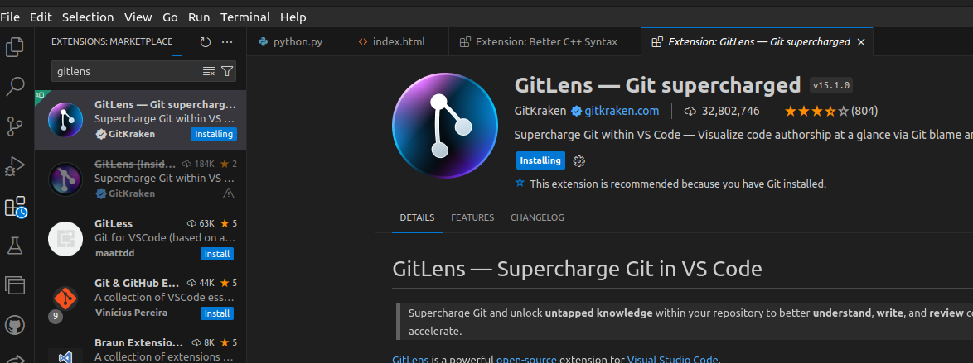

1. ESlint for linting

